Data Analytics : Can Fundamentals Alone Predict Market Reactions? A Machine Learning Approach to Post-Earnings Stock Movement in Indian Sectors

Interim Report
Abhi Vedwa
Walsh College
QM640 V1: Data Analytics Capstone
<Mentor Name>
Winter 2025 Term

Introduction
In Indian financial markets, Quarterly earnings announcements play a critical role in short-term stock price behavior. These disclosures often trigger significant short-term stock price movements; a dynamic that academic research has captured through phenomena like the post-earnings announcement drift (PEAD). However, while it's widely accepted that financial fundamentals such as earnings per share (EPS), profit after tax (PAT), and operating profit margin (OPM%) are central to these movements, most predictive models still rely on a mix of technical indicators, sentiment data, or textual analysis. This makes it difficult to isolate the true informational value of structured financial disclosures.
This study addresses that gap. This study investigates whether structured, numerical financial indicators from quarterly earnings reports , closing price of T, T+1, T+2 and T+3 without any additional data sources can predict the direction of stock price movement (up or down) in the three trading days following the announcement. To explore this, we apply supervised machine learning models (Logistic Regression, Random Forest, and XGBoost) to data from 45 listed Indian companies across five sectors.
What sets this work apart is its strict focus on structured data, 3 day closing price and its cross-sector analysis for Indian market only. Unlike prior research: Huanget al.(2021), Sherasiya and Jadeja (2023) that either targets long-term trends or uses blended inputs, Zhao et al. (2023) provided evidence that financial features could yield robust models in emerging markets like China but also relied on price-based features. Ampomah et al. (2020) compared ensemble methods but did not isolate the post-earnings effect, while Saberironaghi et al. (2025) provided a comprehensive survey highlighting the under-utilization of earnings-based triggers in short-term forecasting. We will also compare model performance and assess which financial indicators most influence predictions using interpretation tools like SHAP or permutation importance.
In doing so, the study contributes a transparent, replicable framework for short-term stock movement prediction and clarifies how much insight quarterly fundamentals truly provide, sector by sector, model by model.

Scope and objectives

Scope
This study focuses on listed Indian companies across five selected sectors, aiming to predict short-term stock price movement (Up/Down) in the three trading days post quarterly earnings announcements. The analysis exclusively uses publicly available, structured numerical financial data(e.g., EPS, PAT, OPM%) and does not include unstructured inputs such as sentiment, analyst commentary, news, or AI-generated content. This study intentionally excludes unstructured inputs to isolate the predictive power of structured financial disclosures.
Short-term stock movement refers to the price change direction (Up/Down) over three trading days following the earnings announcements(T+1 to T+3). Five sectors will be chosen to ensure diversity in market dynamics and will represent a unique combination of market capitalization, and availability of quarterly disclosures.

Objectives
To evaluate whether structured financial disclosures alone can predict post-earnings stock price direction using supervised machine learning. The study also compares model performance across sectors and algorithms while identifying the most influential financial indicators. Research problems must be clearly defined (present at least four research questions pertinent to the study.

Research Questions (RQs) and Methodology
RQ1: Can structured quarterly financial indicators alone predict the direction of short-term
stock price movement following earnings announcements.
Methodology: Supervised classification models such as Logistic Regression, Random Forest, and XGBoost, will be trained on labelled financial indicators derived from quarterly earnings reports. The dependent variable will be a binary label indicating whether the stock moved “Up” or “Down “in the three trading days following the announcement. The models will be evaluated using metrics such as accuracy, precision, recall, and F1-score
  - RQ2:Which structured financial indicators (e.g., EPS, PAT, OPM%) are most influential in determining short-term post-earnings stock price direction?
Methodology: To assess feature importance, the study will apply model interpretation techniques such as SHAP (Shapley Additive Explanations) and permutation importance. These methods will help rank the financial variables based on their contribution to the model’s prediction, thereby identifying the most influential indicators across all trained models.
  - RQ3:How does the predictive performance of structured financial indicators vary across different sectors in the Indian equity market?
Methodology: The test dataset will be stratified by sector, and model performance will be evaluated separately for each group. Classification metrics, primarily F1-score and accuracy will be used to identify whether certain sectors yield higher or lower predictive accuracy. This will help determine whether the predictive strength of financial indicators is sector specific.
  - RQ4:How does the performance of different machine learning algorithms (e.g., Logistic Regression, Random Forest, XGBoost) compare when trained exclusively on structured financial indicators?
Methodology: A comparative analysis will be conducted using three machine learning models: Logistic Regression, Random Forest, and XGBoost. Each model will be evaluated using stratified k-fold cross-validation. Performance will be compared using classification metrics such as F1-score, accuracy, and ROC-AUC to determine which algorithm is most effective for this prediction task.
Literature survey
To be added

Data Description
GITHUB REPO: abhivedwa/Walsh-MS_CapstoneProject
This dataset MS_Capstone_Final_Raw_Dump.xlsx has raw structured, quarter-by-quarter panel covering India’s top 45 listed companies across five sectors from July 2022 to July 2025 (13 result cycles → ~585 rows). This “raw” layer intentionally avoids normalization or feature engineering so downstream analysis can be audited and reproduced easily.
For each company and quarter, we record:
- The official earnings announcement date (“Result Date”),
- The main financial statement numbers as published for that quarter, and
- The stock’s closing prices on and after the announcement (T, T+1, T+2, T+3), aligned to actual trading days.

Columns in the file (what each means)

Name | Description | Derived | Formula / Rule (if derived)
Company | Listed company name | No | —
Ticker | Indian exchange symbol | No | —
AV_Ticker.BSE | Alpha Vantage symbol | No | —
Sector | One of 5 sectors | No | —
Cap Category | Large / Mid / Small | No | —
Period | Quarter label (e.g., “Jun 2024”) | No | —
Result Date | Earnings announcement date | No | —
Sales | Operating revenue (non-BFSI) | No | —
Expenses | Operating costs | No | —
Operating Profit | Operating profit before OI/Int/Dep | No | —
OPM % | Operating margin percent | No | —
Other Income | Non-core income | No | —
Interest | Finance cost | No | —
Depreciation | Depreciation & amortization | No | —
Profit before tax | PBT | No | —
Tax % | Effective tax rate | No | —
Net Profit | Profit after tax (PAT) | No | —
EPS in Rs | Earnings per share | No | —
Revenue | Top line (BFSI usage) | No | —
Financing Profit | Profit from lending (BFSI) | No | —
Financing Margin % | NIM / margin (BFSI) | No | —
_T_date | Trading day used for T | Yes | If trade on Result Date, use it; else nearest prior trading day
Closing Price (T) | Close on _T_date | Yes | Close for _T_date from source cascade
_T1_date | Next trading day after _T_date | Yes | First trading day after _T_date
Closing Price (T+1) | Close on _T1_date | Yes | Close for _T1_date
_T2_date | Second trading day after _T_date | Yes | Second trading day after _T_date
Closing Price (T+2) | Close on _T2_date | Yes | Close for _T2_date
_T3_date | Third trading day after _T_date | Yes | Third trading day after _T_date
Closing Price (T+3) | Close on _T3_date | Yes | Close for _T3_date
3-Day Avg Price Post Result | Avg of Closing Price of T+1, T+2, T+3 | Yes | Avg of Closing Price (T+1), Closing Price (T+2), Closing Price (T+3)
3-Day Return (%) | 3 Day return | Yes | ((3-Day Avg Price Post Result - Closing Price (T))/Closing Price (T))* 100
Movement Label (1,0) | Target Variable | Yes | IF(3-Day Return (%) >= 1, 1, 0)

Note: These are exchange closes, not averages or adjusted values. We intentionally keep them raw, so any feature creation happens later and transparently.

Data Extraction and Source
Quarterly fundamentals & result dates (primary):
- IndianAPI– Quarterly results:
https://stock.indianapi.in/historical_stats?stock_name={TICKER}&stats=quarter_results
- IndianAPI – Board meetings / results calendar (to extract Result Date):
https://stock.indianapi.in/board_meetings?stock_name={TICKER}
(filtered for “Result/Financial Results” outcomes where available)
Daily prices (three-stage sourcing, in order of preference):
- Official exchange Bhav copy (preferred)
  - BSE daily EOD “Bhav copy” CSV (public archive).
  - NSE daily EOD “Bhav copy” CSV (public archive)
- IndianAPI (daily-like only; not weekly aggregations)
  - https://stock.indianapi.in/historical_data?stock_name={TICKER}&period=1yr&filter=price
We accept only responses where meta.is_weekly == false (daily granularity).
- Alpha Vantage (used only when 1 & 2 were unavailable for a specific event)
  - https://www.alphavantage.co/query?function=TIME_SERIES_DAILY&symbol={AV_TICKER_BSE}&outputsize=full&apikey=...

How dataset was built.
- List of companies & sectors
Start from 45 target companies grouped into five sectors (IT, BFSI, FMCG, Pharma, Auto) and labelled by cap bucket (Large/Mid/Small).
- Quarterly results pull
For each ticker, call IndianAPI historical_stats?stats=quarter_results and capture the quarter’s figures exactly as returned (e.g., Sales, OPM %, Net Profit, EPS).
  - We do not normalize or rename industry-specific fields (e.g., banks’ “Revenue”, “Financing Profit” stay as-is).
- Result Date extraction
From IndianAPI board_meetings we identify the official earnings announcement date (Result Date).
  - Where companies disclose multiple meetings, we pick the row indicating “Financial Results” outcomes for the quarter’s period label.
- Price alignment logic (strict, event-anchored)
For each (Ticker, Result Date):
  - T:
    - If the stock traded on the Result Date, set _T_date = Result Date and Closing Price (T) = close on that date.
    - If no trade (holiday/maintenance/IPO gap etc.), set _T_date to the nearest previous trading day and Closing Price (T) to that day’s close.
    - Sources used in order: (a) Exchange bhavcopy; (b) IndianAPI historical_data only when meta.is_weekly=false; (c) Alpha Vantage TIME_SERIES_DAILY as last resort.
  - T+1, T+2, T+3:
Move forward through the next trading days from _T_date (not calendar days), capturing each day’s official Close and the actual trading date.
    - The same source preference order applies (bhavcopy → daily-like IndianAPI → Alpha Vantage).
    - We skip weekends and exchange holidays automatically by following the trading calendar implied by the data source.
  - Never forward-fill missing closes; if a source is unavailable for that event, we try the next source. If all sources fail, fields remain blank for that event (later backfilled where possible).
- Integrity checks
  - All rows from the results table are kept even if prices are missing; prices are opportunistically filled by the above cascade.
  - We record the actual _T_date, _T1_date, _T2_date, _T3_date to show which trading days were used—this makes every price traceable to a dated close.

What is not done in this raw layer
- No unit scaling, currency conversions, or inflation adjustments.
- No deduping beyond exact company-quarter keys; if a company revises a quarter, we keep the latest pull and log the source date.

Analysis

Data Analysis.
The study analyses quarterly earnings results from 2022 to 2025 for 45 companies across five sectors and three market cap categories. With 3 years ×4 quarters = 12 observations per company, this results in a dataset of approximately 540 samples.
Using the confidence interval method for binary classification with 95% confidence level (Z = 1.96), expected proportion p = 0.5, and margin of error e = 0.05, the required sample size is calculated as:
n = (Z² ×p ×(1 − p)) / e² = (1.96² ×0.5 ×0.5) / 0.05² ≈ 384
Since 584 > 384, the dataset size is statistically adequate for binary ML classification analysis.
Schema is complete; types are consistent with all event dates parsed to datetime64[ns]. Missingness is structurally sector-driven: BFSI fields (Revenue, Financing Margin %) are absent in ~468 rows, while non-BFSI metrics (Sales, OPM %) are missing in 117 BFSI rows; price/date fields are >99% complete (only 1 NA in returns/labels). Class balance is mildly skewed (Down=344, Up=240; 59/41). Temporal QA flags 67 records with _T_date misaligned vs Result Date and 114 cases with non-monotonic T→T+3 ordering, warranting review (holiday/calendar effects vs data entry). Range sanity highlights plausible but extreme values—Financing Margin % −39→39 (88 flags) and Tax % −88→3925 (15 flags)—while OPM % is well-bounded. The 3-day return distribution is centered near zero (μ≈0.29%, σ≈4.28%, min −12.1%, max 19.1%).

EDA results
EDA shows severe multicollinearity among level variables; near-zero linear/monotone association between levels and the 3-day move; small, sector-dependent non-linear traces; and economically plausible outliers.
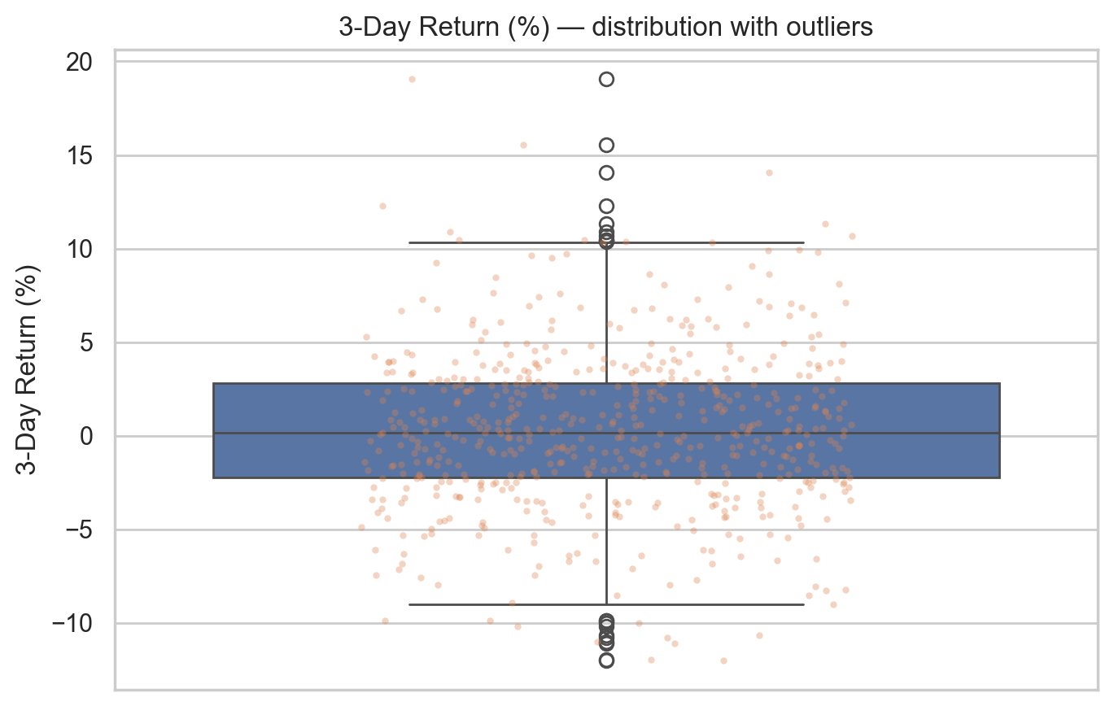
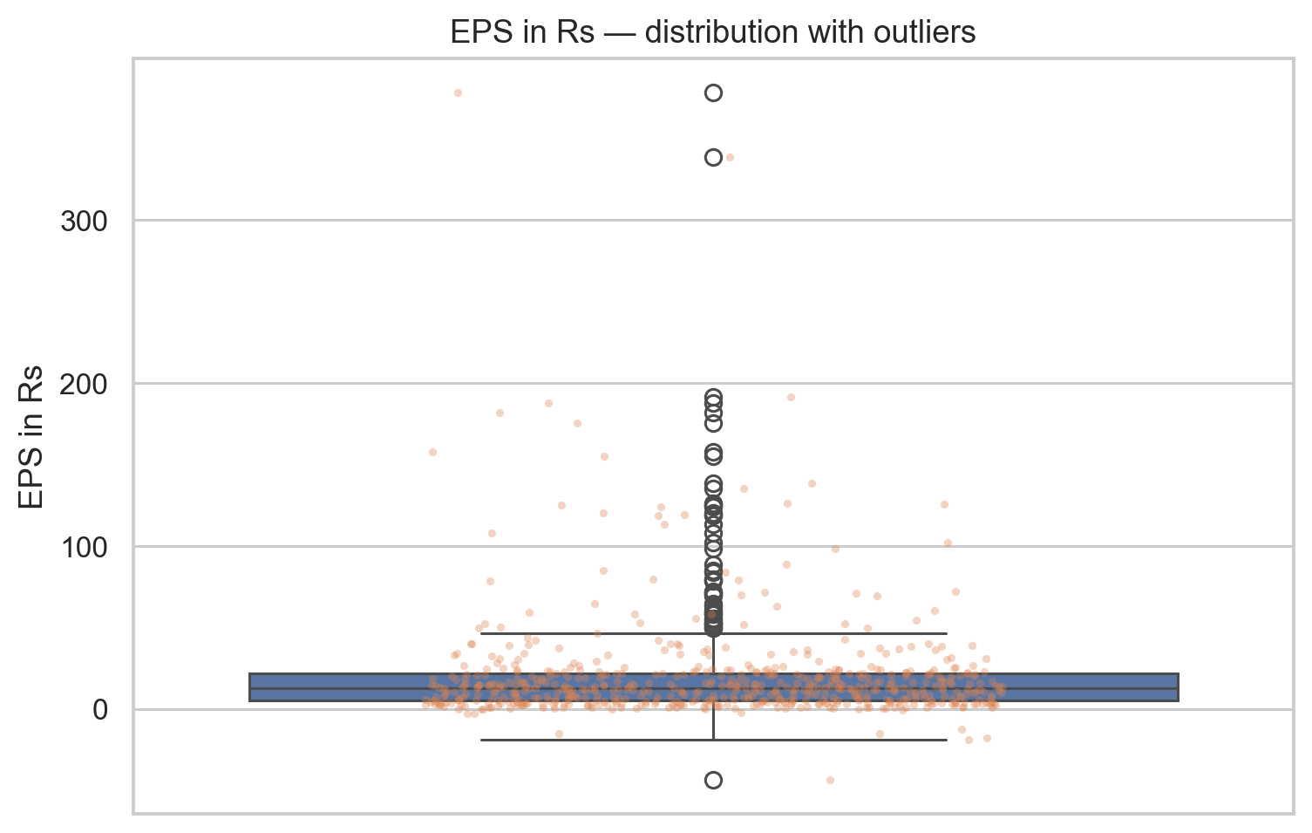
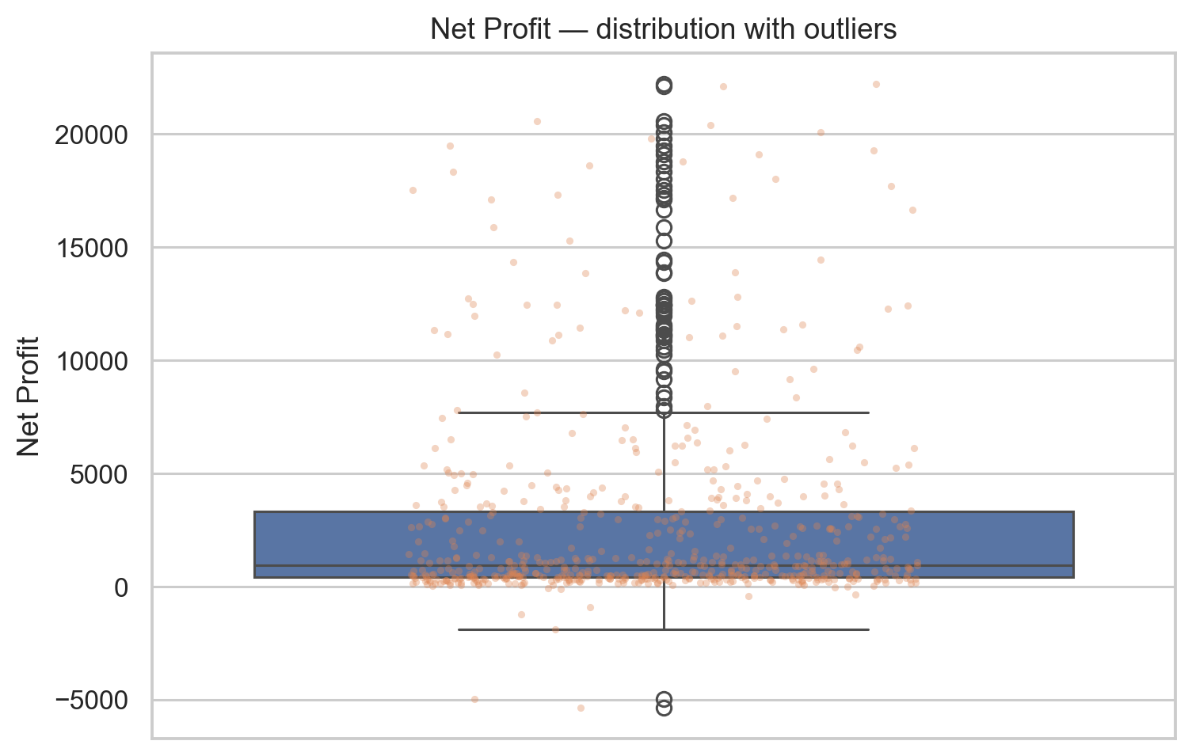
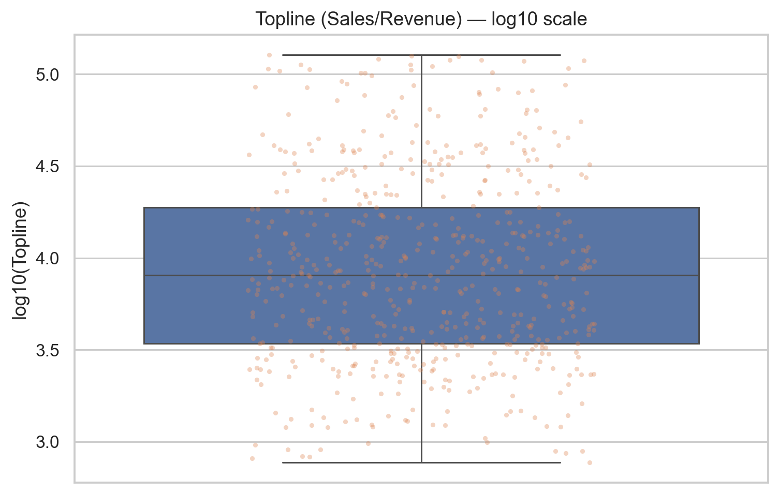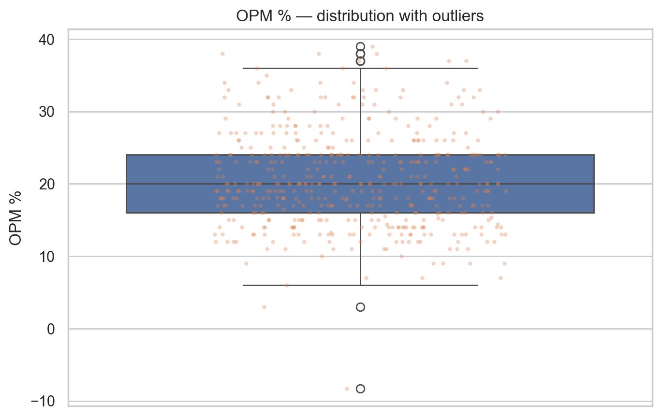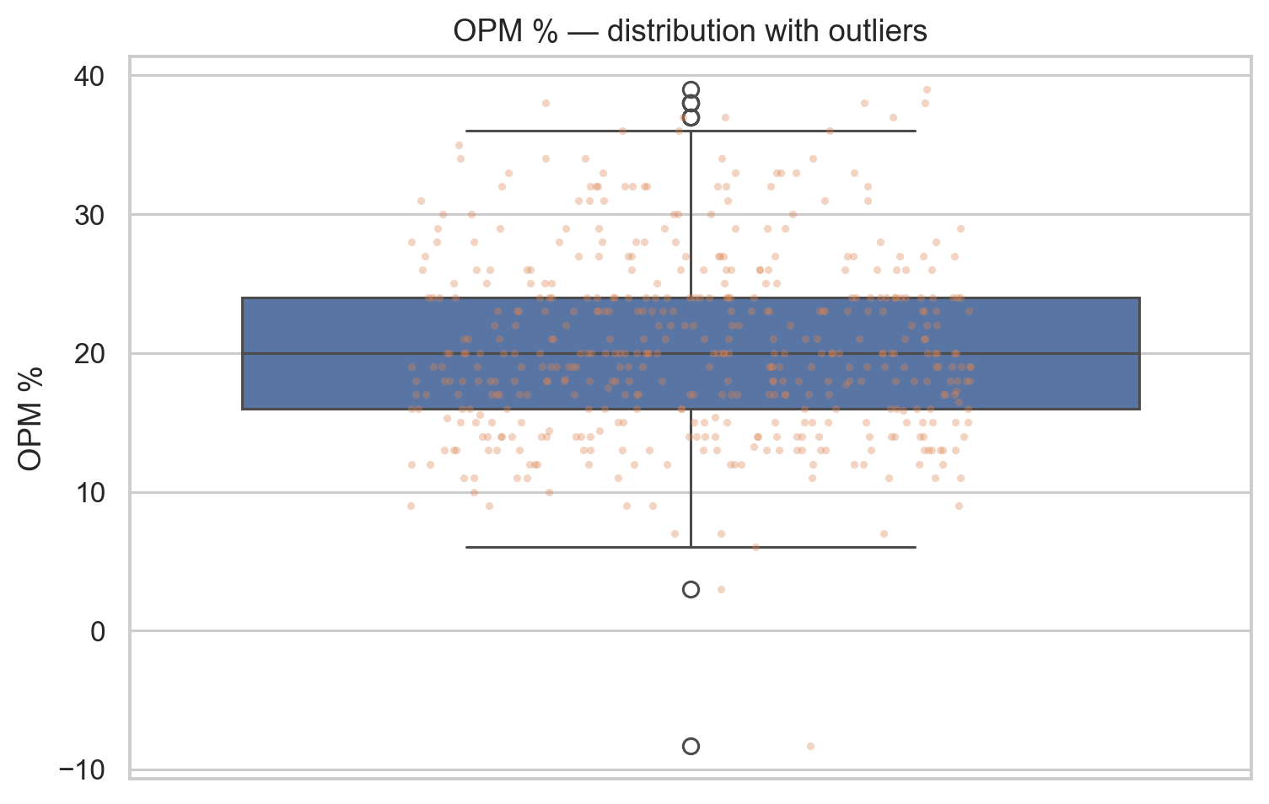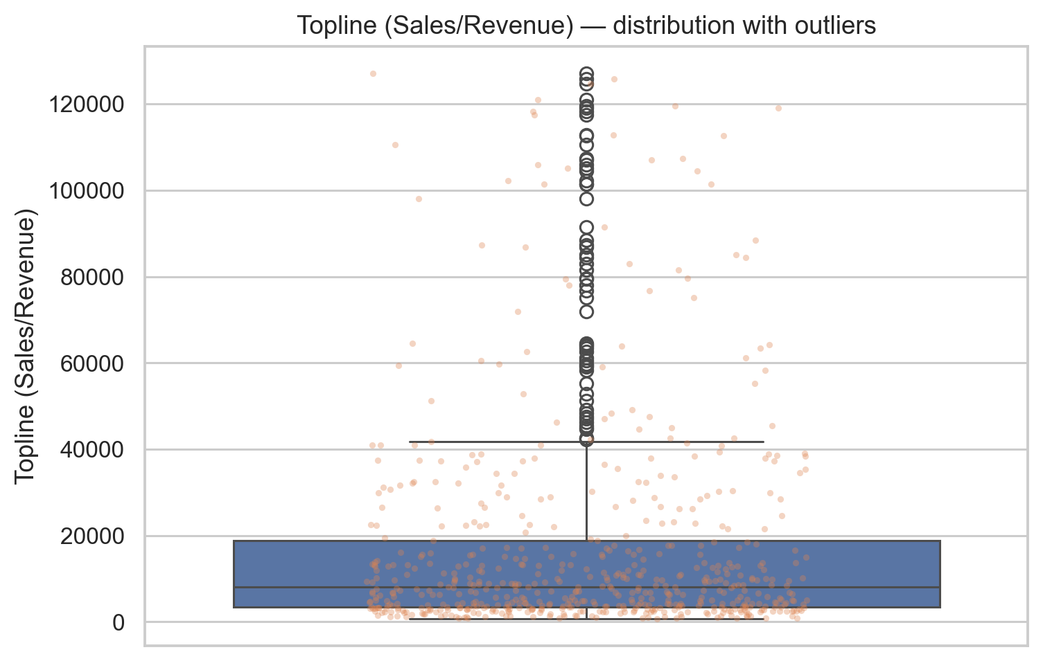

Correlation family (Pearson, Spearman, point-biserial)
The Spearman heatmap (Fig. 5) reveals tight accounting clusters: Net Profit ↔ Profit Before Tax (≈1.0), Sales ↔ Expenses (≈1.0), Revenue ↔ Interest/Financing Profit (BFSI block), and high associations between post-event prices (T, T+1, T+2, T+3). This is classic multicollinearity that can destabilize linear coefficients and confound naive feature importances. Crucially, correlations between fundamentals and 3-Day Return (%) are near zero; the largest |r| is ≈ 0.07 (slightly negative) and the largest |ρ| ≈ 0.09 (slightly positive for Revenue). Point-biserial correlations with the Movement Label are also tiny (e.g., OPM% r ≈ −0.093, marginal p-value), confirming weak linear separation by levels.
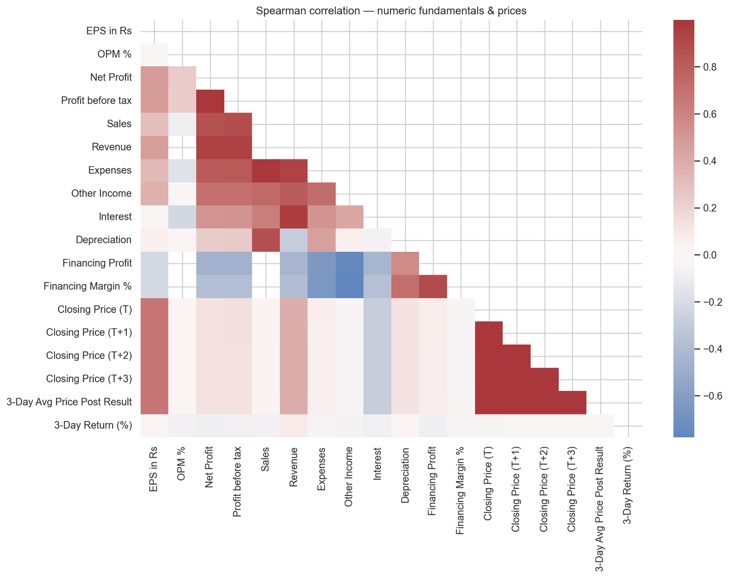

Mutual Information (MI)
MI captures non-linear dependencies without monotonicity assumptions. Aside from the leakage variable (3-Day Return, MI ≈ 0.68; excluded from features), the top MI scores among fundamentals are small—e.g., Sales ~0.027, Financing Margin% ~0.023, Depreciation/Other Income ~0.008—indicating at best subtle non-linear structure.
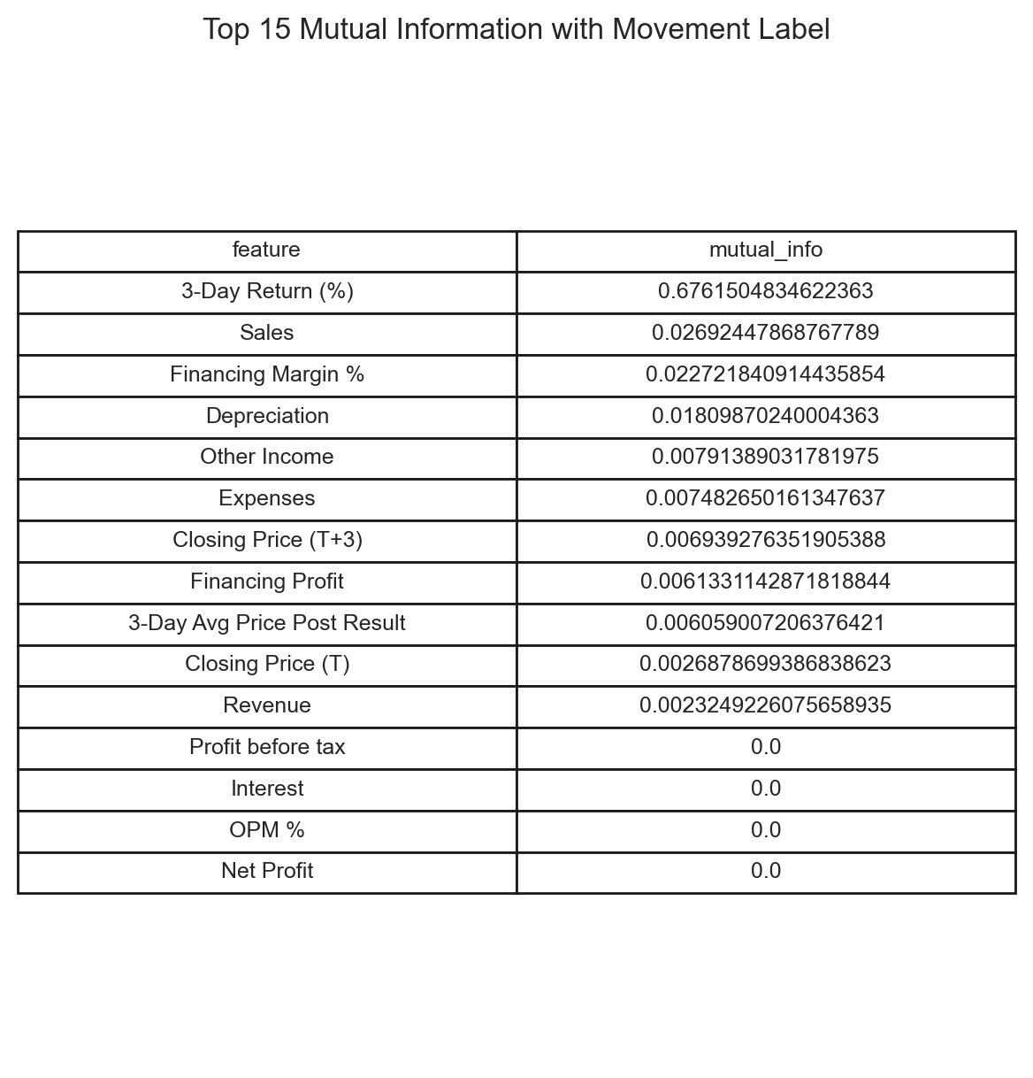
Both families converge on the same story: absolute levels have weak explanatory power for short-horizon direction, while the space is dominated by redundant (collinear) signals. If fundamentals matter at this horizon, it is likely through changes related to a firm’s own history or the composition/quality of earnings, not their raw magnitude.

Sector lenses and heterogeneity
Sectoral panels compare Up vs Down distributions within Auto, FMCG, IT, Pharma, and BFSI.
- Auto. Up and Down groups overlap across EPS/OPM/Topline; many high EPS/NP outliers appear in Down, consistent with mean-reversion or expectation miss, not level-driven upside.
- FMCG. Down tends to have larger Topline and slightly higher margins—again, scale does not equate to near-term outperformance.
- IT/Technology and Pharma. Medians are close across classes with wide overlap—levels remain non-discriminative.
- BFSI. Financing Margin% ranges from −40% to +40%. Up/Down outcomes interleave across the range, and the scatter vs return shows no monotone relation, arguing for Financing Margin rather than its level.
Average sector returns (Fig. X) are positive for Auto, Pharma, IT, FMCG and negative for BFSI (≈ −0.45%). Because base rates differ by sector, both modelling and evaluation must be sector-aware to avoid Simpson’s paradox effects.
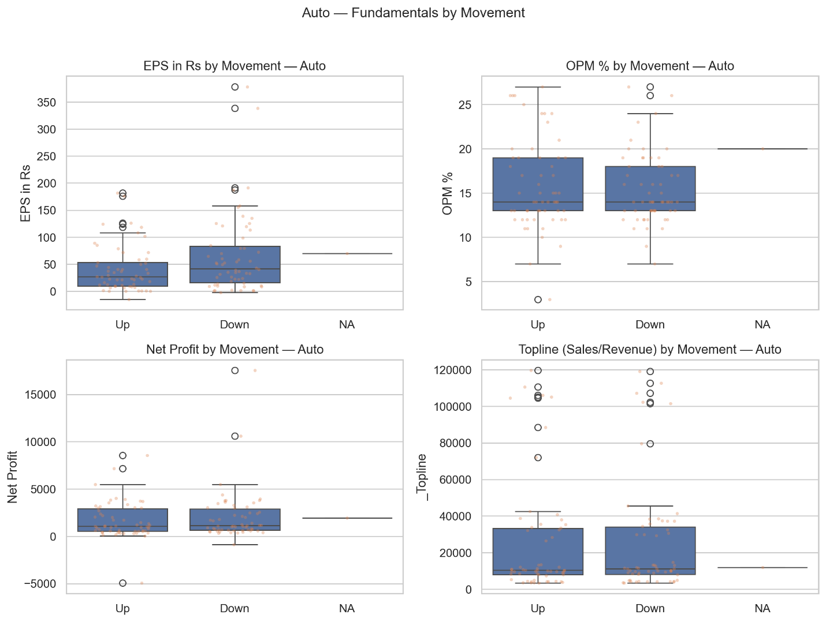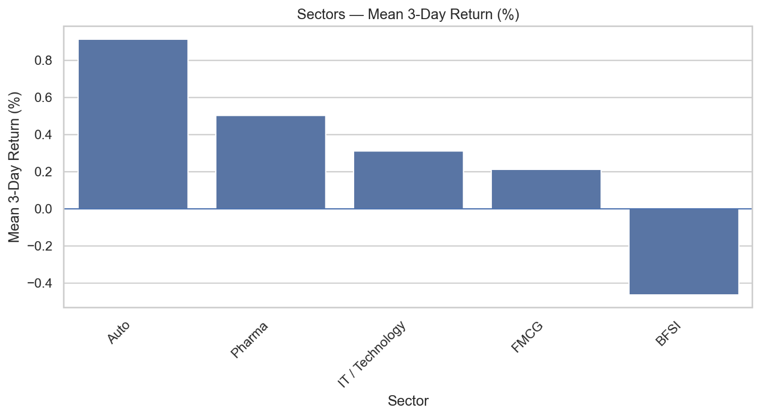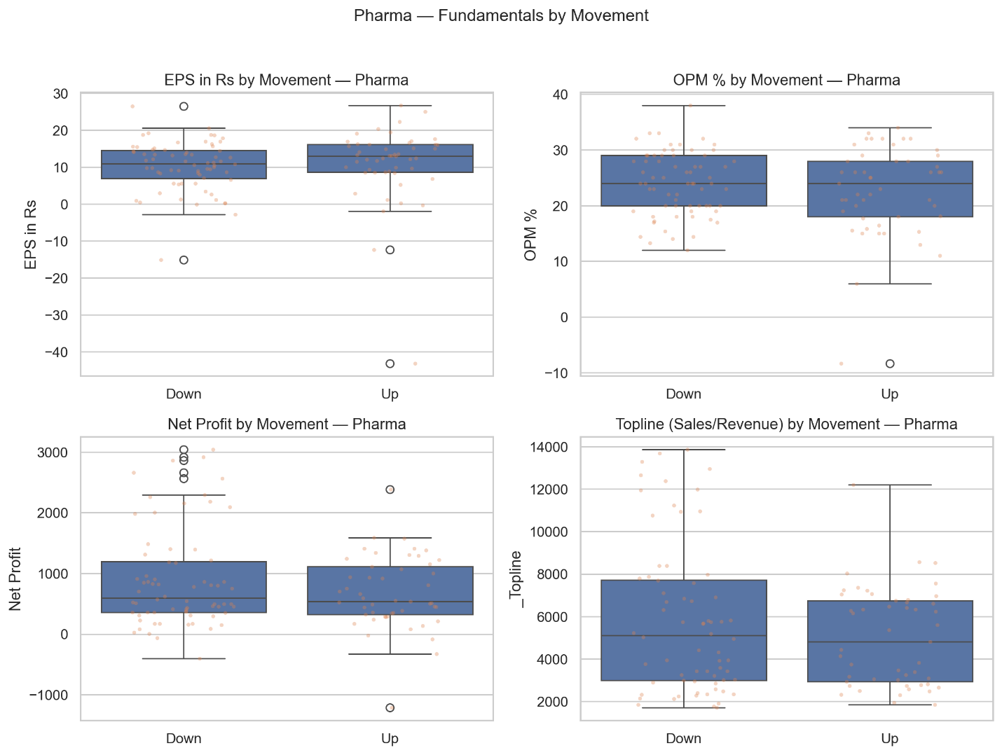

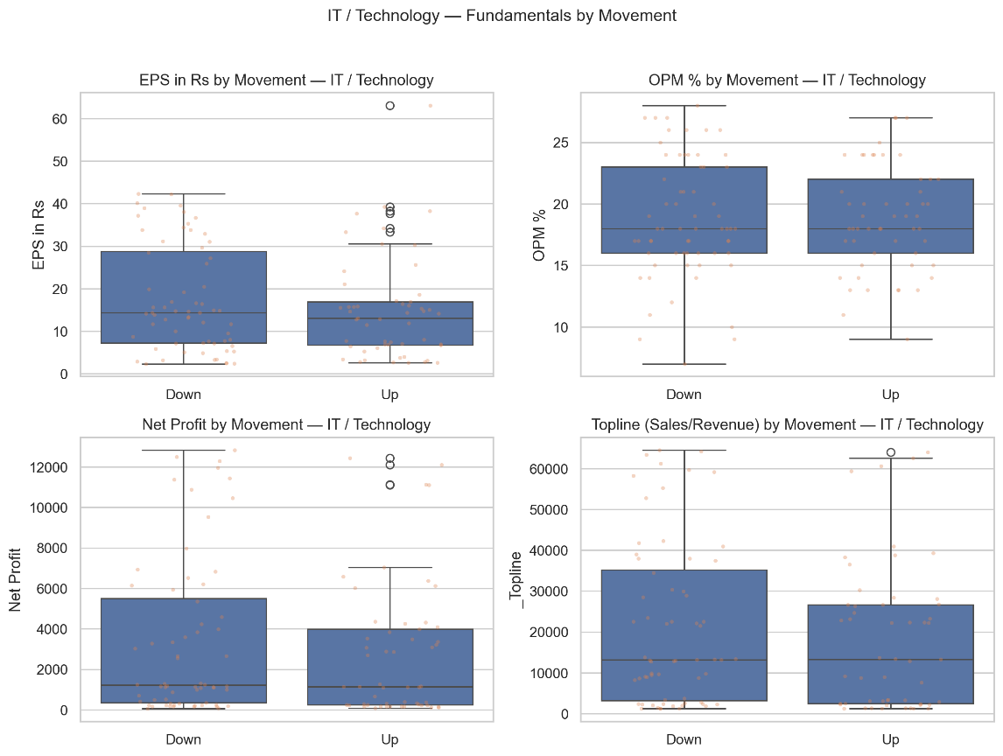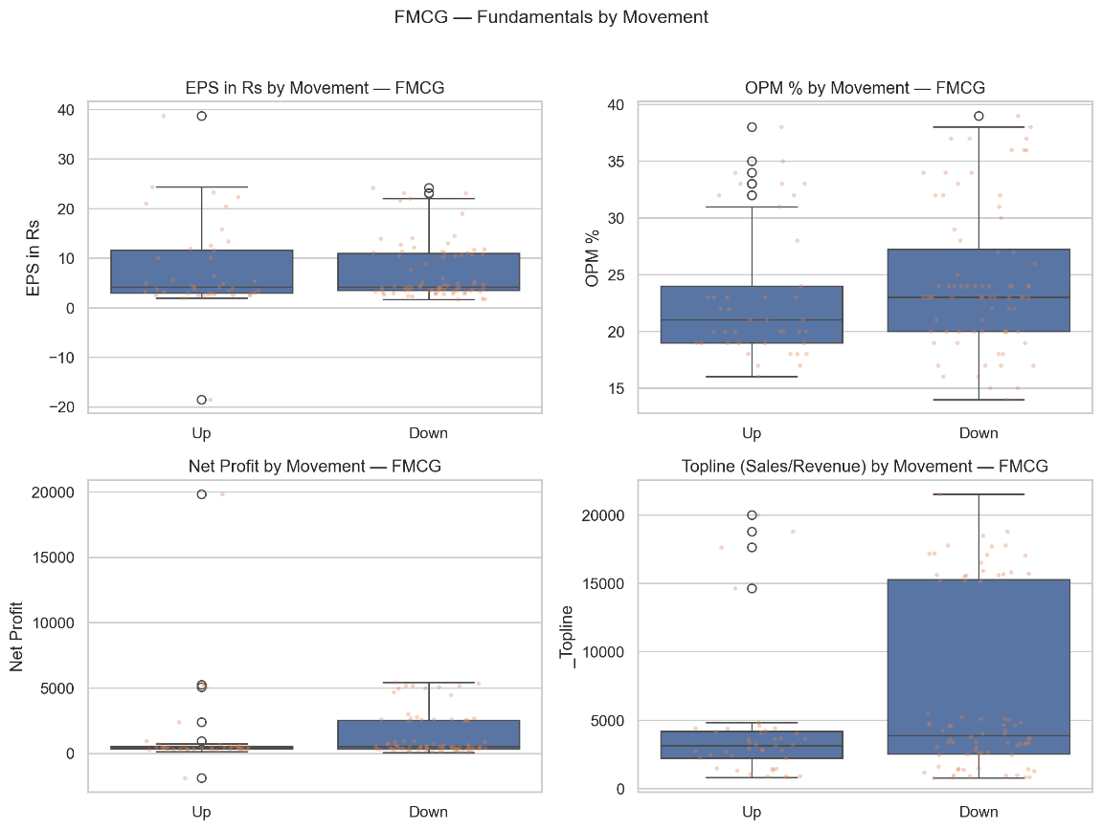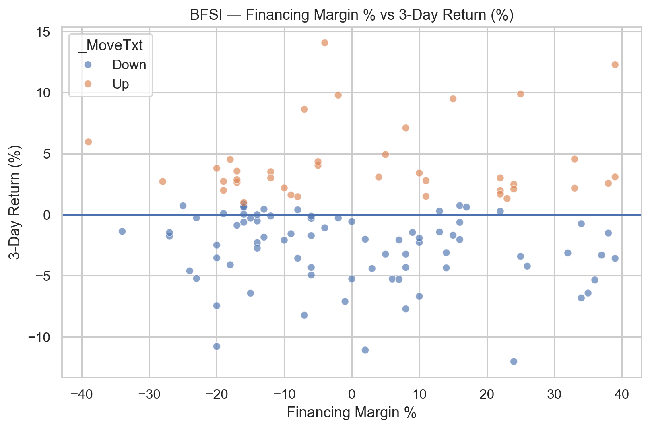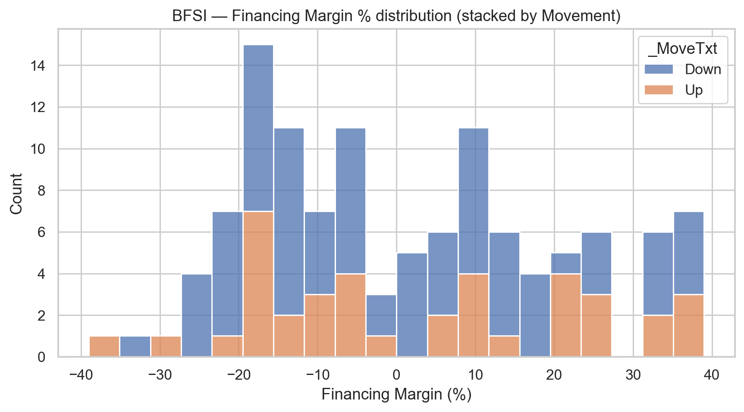

Outliers and robustness choices
EPS and Net Profit are heavy-tailed; OPM% is bounded; short-horizon returns have modest tails. We retain outliers to preserve economic realism and apply robust transforms only where necessary for specific estimators: log1p for EPS/NP in linear models; optional winsorization at 1%/99% for EPS if coefficients are unstable. Tree ensembles are robust and can consume raw values.
Feature | N (non-null) | Q1 | Q3 | IQR | Lower Fence | Upper Fence | Outliers (count) | Outliers (%)
Topline (Sales/Revenue) | 585 | 3433 | 18790 | 15357 | -19602.5 | 41825.5 | 59 | 10.09
Net Profit | 585 | 410 | 3336 | 2926 | -3979 | 7725 | 58 | 9.91
EPS in Rs | 585 | 5.22 | 21.96 | 16.74 | -19.89 | 47.07 | 48 | 8.21
3-Day Return (%) | 584 | -2.2325 | 2.8075 | 5.04 | -9.7925 | 10.3675 | 20 | 3.42
OPM % | 468 | 16 | 24 | 8 | 4 | 36 | 9 | 1.92

